DUNDONALD BLUEBELL FC

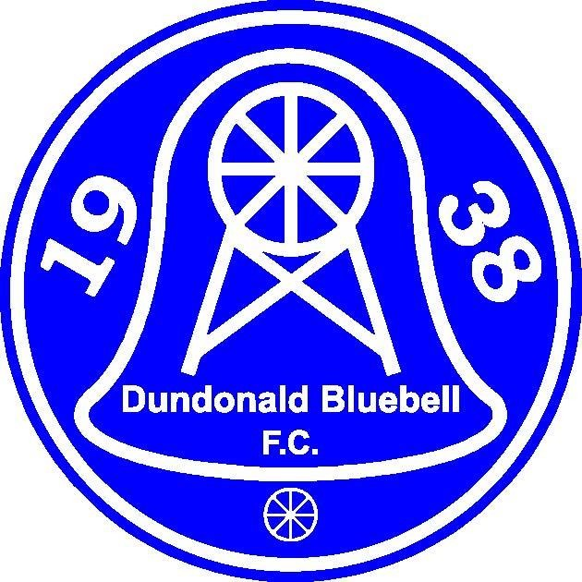




Medical Risk Assessment and Medical Plan

January 2020

INTRODUCTION
This document combines the Medical Risk Assessment and Medical Plan. It addresses:
- Organisation and infrastructure relating to medical matters;
- Identifiable medical risks and how these are controlled;
- General provisions for medical care.

INFRASTRUCTURE AND ORGANISATION
Access for Emergency Vehicles into Dundonald Bluebell, Moorside Park is accessible by public road at Dundonald Park at the North End of the ground. The entrance would permit direct access for emergency vehicles to the pitch and covered enclosures. Emergency vehicles attending at the North entrance would be approximately 15 metres from the pavilion and Social Club/ First Aid Room.

First Aid Facilities
The principal first aid room is is directly accessible from the main entrance and does not require access through either dressing room or any other room. It contains a defibrillator, basic first aid equipment, seating facility and hot and cold running water supplies. There is a separate toilet facility within the room. Our multi-functional ‘Managers Room’ which is situated in the pavilion can also be used for first aid or doping control.

Organisation and Personnel
Dundonald Bluebell (“the Club”) has an association with a Doctor for advice and guidance on all medical matters. The Doctor is in attendance for major matches (where attendance of greater than 500 is anticipated). The Club also ensures that there is at least one qualified Sports First Aid staff member present at all matches. There is a Safeguarding Officer present at every home match. This person will be located at the entrance to the dressing rooms and is the focal point for co-ordination of messages during the match. He will make any safety announcements and will have immediate access to a telephone to communicate with others including the emergency services to ensure expedited management of any health and safety issues.

IDENTIFIABLE MEDICAL RISKS

INJURY TO PLAYERS
  - Description
The most likely source of a medical issue is the injury to players during the normal course of the match. This can cover the spectrum of minor injury which is treated pitchside before the player returns to the game to serious injury requiring immediate intervention and hospitalisation

Current Arrangements
The club will ensure that there is a qualified sports first-aider present at all matches. A stretcher is available in the dressing rooms which will enable removal of players from the pitch to the first aid room in the dressing rooms if the player requires assistance to leave the pitch. The nearest accident

and emergency department is at the Victoria Hospital, Kirkcaldy, which is 15 minutes from the ground under normal traffic conditions. The first aider looking after an injured player will make arrangements through the Safe Guarding Officer either to arrange transport for a player to the hospital for further assessment or to call the emergency services if immediate medical care is required. The club also has a defibrillator installed in the First Aid Room and qualified personnel to operate are in attendance. The risk of injury to players does not vary significantly between normal and major matches therefore this assessment applies to all matches.

Assessment
The current arrangements are satisfactory but it is recommended that the procedures for removal of the player from the pitch and making arrangements for onward transport are rehearsed at least annually.

Actions Required
Annual rehearsal of arrangements as above

INJURY TO SPECTATORS

Description
The following risk factors can be considered collectively for assessment purposes:
    - FIRE – there is identifiable risk in the dressing rooms, Club House and First Aid Room. These are inspected by the local fire authorities. The risk is assessed as moderate for these areas are well manned on match days.
    - STRUCTURAL FAILURE – the identifiable sources of risk are the three enclosure structures. These are regularly inspected. The risk is considered negligible under normal circumstances to slight in high winds.
    - EVACUATION – there is negligible risk under normal operating conditions rising to moderate in a “panic” situation in a match a maximal capacity. This risk is mitigated because (a) unplanned evacuation is extremely unlikely (b) planned, orderly evacuation reduces the risk.
    - GENERAL – There is a general risk to spectators from slips, falls or other accidents. This is controlled by the maintenance of the ground in good condition. This risk is proportional to the number of spectators. During winter months slippery surfaces will have salt/ grit applied as a matter of course

Current Arrangements
Direct injury from fire and structural failure has been reduced to acceptable levels by the inspection and maintenance required by the local authorities. In the event that there was a risk of structural failure this would be controlled by closing off the affected area of the ground or cancellation of the match. Other risks are proportional to the attendance. The club will ensure that there are additional first aid staff present for matches where more than 500 spectators are expected. The precise arrangements will be agreed in discussions with the police, NHS and first aid suppliers

Assessment
Arrangements are considered adequate for all foreseeable risks.

Actions Required
None.

ILLNESS
  - Description
There is a general risk of illness whenever there are gatherings of people. There are no identifiable risk factors which suggest that players and spectators at a match are at greater risk of illness except the established risks that can be associated with any situation in which there is potential stress (e.g., heart attacks in those with pre-existing risk factors).

Current Arrangements
Immediate care is the same as for physical injury. Anyone becoming ill will be made comfortable and the condition assessed by a first aider or doctor. In an emergency an ambulance will be called – DIAL 999 – otherwise advice can be obtained from NHS Fife Dial 01383 623623 or 01592 643355 or NHS 24 Helpline 111 or Dundonald Bluebell Club Doctor.

Assessment
Current arrangements are satisfactory

Actions Required
None

GENERAL MEDICAL PROVISIONS
The following personnel must be present at each home match:
- At least one qualified sports first aider;
- A Safeguarding Officer to act as the single point of communication
Where there is an anticipated attendance of greater than 500, in addition to the above:
- Attendance by a club doctor is advised;
- Additional first aid personnel should be provided by request from the first aid service providers.
The club Doctor is responsible for advising on equipment to be present in the first aid room and in the medical bags available to sports first aiders and the sports first aiders are responsible for checking that the equipment is present and in good order. The team must be accompanied by a sports first aider at all matches, including away matches.

Document Created – January 2019

Reviewed: - Robert Dick 17/10/2026

